ACKNOWLEDGEMENTS

Acknowledgements

“The beautiful fragrance that accompanies completion of our project task would be incomplete without the appreciation to the people who made it possible. However, words are not enough to express the sense of gratitude to everyone who helped us directly or indirectly”.

First and foremost we would express our sincere gratitude to our beloved principal
for the strong encouragement in bringing out this project.

We are grateful to Prof. Rachna Sharma, HOD of MCA Department who spared her time in pursuing us in doing the project.
We also extend our regards to our project guide Prof. Uma B, Senior Lecturer, Department of MCA for his timely guidance, painstaking attention and suggestion at every stage during our project.
Last but not least we wish to express our gratitude to our family members, friends and all the well-wishers who stood behind us.

CONTENTS

- Abstract………………………………………………………………………… 04
- Introduction……………………………………………………………………. 06
- Requirement Specification……………………………………………………. 08
- Software Development Life Cycle……………………………………………..10
- System Analysis………………………………………………………………....13
- Design……………………………………………………………………………19
- Coding……………………………………………………………………………25
- Testing……………………………………………………………………………36
- Screenshots………………………………………………………………………37
- Future Enhancements……………………………………………………………42
- Conclusion……………………………………………………………………….42
- Bibliography……………………………………………………………………..42

ABSTRACT

1. ABSTRACT

The goal of Compcart is to provide an effective way of designing the system. It makes the work easy in this materialistic world and also has the best feature of selecting the components in the required price range.
Admin module consists of admin who focuses on updating of the components , delivering of products and verification of the customers.
User Module:
User has to enter the price range and select the required category and provide his contact details and buy the product. The admin will call to the customer and confirm the order and deliver the product, it’s a cash on delivery process.
Categorization helps in selecting the required product based on the classification which lead in saving of time.
- Products:
- Business- the systems which are mainly required for business purpose with minimum specifications are provided .Discount offers are provided.
- Gaming- Focused mainly for the gamers and the organizations which makes business out of it.
- Customized – Each user has their own requirements and it mainly focuses on individual specifications with in their price.
- Personal System- It focuses on the minimum requirement of the common user.

- Accessories:
- Hardware- Focuses on all the individual hardware components required by the user
- Networking- Focuses on the all the components which are required in the established of the network efficiently.
- Software – Focuses on the latest Operating system, updated version of licensed antivirus and all the office tools, education, utilities and gaming.
- Laptop Accessories – Focuses on the basic accessories which are required to maintain the laptops.

INTRODUCTION

2. INTRODUCTION

2.1 INTRODUCTION TO THE PROJECT:

COMP CART as the name implies it’s a basket of user’s choice to choose the required system with in the price range ,so its known as the user friendly application.
In this project , my focus is towards- *Admin Module
The Administration Module in this project mainly focuses on the database transactions.
- Maintain permanent historical records of customers of products and services.
- Control the scheduling of delivery of the products.
- Confirmation and the rejection of the orders.
In the admin module,
>> Admin has the authenticated login to the site, Also has the privilege to insert and update the new products available for the user.
>>Discount offers and price range of the products are set by the administrator.
>> Admin also focuces on the confirmation and rejection of orders ,also has a track of the delivered orders.
Over all Comp Cart is an efficient way to design your system

REQUIREMENTS
SPECIFICATION

3. REQUIREMENTS SPECIFICATION

3.1 FUNCTIONAL REQUIREMENTS:
- Provision for admin to login into his respective account.
- Once the buyer gives the price range, they will be given the products for which the prices are sealed.
- The buyer is given discount offers based on the product and their price.
- Admin confirms the order of the customer and it’s a Cash on delivery process.

3.2 HARDWARE REQUIREMENTS:

- HDD: 10Gb
- RAM: 512 MB
- Processor: Pentium 4 CPU 3.06 GHz

3.3 SOFTWARE REQUIREMENTS:

- Operating System: Windows XP or Higher Version
- Platform: WAMP Server
- Scripting : PHP
- Database: My SQL
- Browser: Google Chrome

SOFTWARE DEVELOPMENT LIFE CYCLE

4. SOFTWARE DEVELOPMENT LIFE CYCLE
For our project, the SDLC model that we have followed is the Waterfall Model.
WATERFALL MODEL:

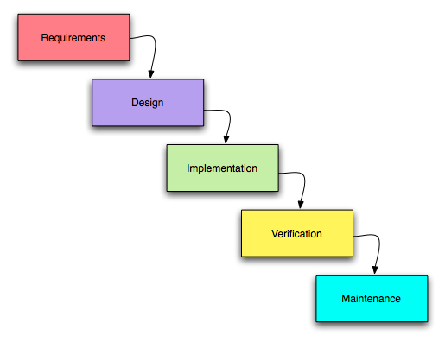

Features of Waterfall Model:
- A waterfall model is easy to follow.
- It can be implemented for any size project.
- Every stage has to be done separately at the right time so you cannot jump stages.
- Documentation is produced at every stage of a waterfall model allowing people to understand what has been done.
- Testing is done at every stage.
Advantages of Waterfall Model:
- A waterfall model helps find problems earlier on which can cost a business less than if it was found later on.
- Requirements will be set and these wouldn't be changed.
- As everything is documented a new team member can easily understand what's to be done.
- Implementers have to follow the design accurately.

Disadvantages of Waterfall Model:
- If requirements may change the Waterfall model may not work.
- Many believe it is impossible to make one stage of the projects life cycle perfect.
- Difficult to estimate time and cost for each stage of the development process.
- Constant testing of the design is needed.

SYSTEM ANALYSIS

5. SYSTEM ANALYSIS
5.1 INTRODUCTION:
The blue print of the developer is nothing but the Requirement Analysis document when the requirement of the system is to be converted into an actual documentation. The programmer has to use his intuition to determine what activities the module is supposed to perform.
5.2 FEASIBILITY STUDY:
The purpose of this document is to describe the various studies that were carried out to validate the feasibility of this module or system in terms of Economic, Technical and Operational
Feasibility.
5.2.1 Economic Feasibility:
Economic justification is the bottom line consideration for most of the systems. But in general, this is the most frequently used method for evaluating the effectiveness of the system. It mainly depends on the cost/benefit analysis. It is found that due to free availability of the required existing hardware resources, the project is feasible economically.
5.2.2 Technical Feasibility:
The technical feasibility is one of the main parameters on which the feasibility of the project is decided. It is found that hardware requirements are easily satisfied, as the requirements are small. The software requirements are met. The skill set required developing the project modules are knowledge PHP, My SQL, HTML, CSS using WAMP Server
5.2.3 Operational Feasibility:
In the project development the project is likely to be operationally feasible if it meets the expectations of the users. In this project the process of accessing the information about the buyers and sellers by the users easily. Users use the system at any point of time.

About PHP
PHP is a server side scripting language designed specially for the Web. Within an HTML page, PHP code can be embedded and it will be executed each time the page is visited . PHP can be used to create web applications ranging from personal websites to e-commerce applications and community web portals i.e. disucssion forums, blogs etc.
Open Source
PHP is freely available for use. The community of open source PHP developers provides technical support and is constantly improving updating the core PHP functionalities. PHP is available at free of cost under PHP General Public License and most of its associative required software's like MySQL, Text Editors and Apache Server are also freely available, so it proves very cost effective for the developers.
Cross-Platform
PHP provides high compatibility with leading operating systems and web servers such as thereby enabling it to be easily deployed across several different platforms. PHP scripts can run across operating systems such as Linux, Windows, Solaris, OpenBSD, Mac OSX etc and also provide support for all major web servers such as Apache, IIS, iPlanet etc.
Power
Several web tasks can now be easily perform using PHP. For example now we can develop from small websites to giant business and organizational websites, informative forums, chatting platforms, CRM solutions, e-commerce shopping carts, community websites, e-business, shopping carts and gigantic database driven sites.
User Friendly
Designed in a user friendly manner, PHP gives more flexibility than C, C++ and ASP and overall helps in increasing traffic to the site.

Quick
PHP is designed to work well with the web, and so things like accessing the GET and POST and working with HTML and URLs are built-ins in the PHP language. This makes it really concise and straightforward to make a website.
Extensions
Being an open source language, a large number of libraries and extensions, to extend its core functionalities, are available for download. The source code of PHP can be modified to include custom created extensions and components thereby increasing its extensibility.
Easy Deployment
There are many hosting companies that will, for a few dollars a month, give you a server running PHP so you can make a website really easily.
Automatically Refreshes
Nowadays developing dynamic websites are in the huge demand due to its specific characteristics like it automatically refreshes and does not need to make much changes manually.

Cummunity Support

A huge advantage that PHP offers is its community. If you are looking for a particular script, chances are another user has already created something similar. Check within the PHP community for availability. Likewise, if you have created a function that others might enjoy, be sure to post the code for others.

Security

PHP offers security as well that helps prevent malicious attacks. These security levels can be adjusted in the .ini file.

About My SQL
MySQL is a very fast, robust, relational database management system (RDBMS). A database enables the users to efficiently store, search, sort, and retrieve data.
MySQL already has guaranteed presence inside large organizations, one of the best known is that NASA uses in processing routine items inside the organization. The ease with which it integrates the web applications is just one of the many benefits it offers, check the following:
- Portability
- Compatibility
- Excellent performance and stability;
- Not requires complex hardware resources;
- Ease of use;
- It is a free software GPL based;
- include the use of various Storage Engines as MyISAM, InnoDB, Falcon, BDB, Archive, Federated, CSV, Solid ...
- Supports transactional control;
- Supports Triggers;
- Supports Cursors (Non-Non-Scrollable and Updatable);
- Supports Stored Procedures and Functions;
- Replication easily configurable;
- GUIs (MySQL Toolkit) easy to use;

WAMP SERVER
Wamp server is a collection of programs you can use to turn your regular desktop PC to a fully compatible web server with HTTP, PHP, MySQL, PHPMyAdmin, SQLBuddy applications. The advantage is that it is easy configurable with the built-in tools. Also it is structured in the way that you have everything you need at a click distance. The configuration screens provide extra information how settings should look like. Another thing would be that the packed applications are configured to be compatible between them, all being automatic configured,
Powerful: By combining all three powerful components (Apache, MySQL, PHP) into one solution, WAMP is indeed one of the most powerful engines ever created.
Free for All: WAMP was created as an open source project. It has a GNU General Public License (GNU GPL). What this means is that it is free for personal and commercial use.
Multiple Add-ons are Available: Multiple add-ons are available for WAMP to extend its functionalities. Current available add-ons are available to add different releases for Apache, MySQL and PHP into WAMP.
Flexibility: WAMP provides an interface to select different releases of Apache, MySQL or PHP. This is especially essential when needed to replicate similar versions running on the production environment.

DESIGN

6.DESIGN
5.1 DATA FLOW DIAGRAM:
Data Flow diagram depicts information flow, the transformation flow and the transforms that are applied as data move from input to output. DFD describes what data flows rather that how they are processed. So it does not depend on how hardware, software and data structure of file organization.
Data Flow diagram shows the information moves through the system and how it is modified by the series of transactions. It is a graphical technique that depicts information flow and the transformations that are applied as data moves from input to output. A DFD may be used to represent a system at any level of abstraction.

USER:

USER
MAIN FORM
SELECT THE CATEGORIE

CHOOSE THE PRODUCT
PLACE THE ORDER
DATA BASE

ADMIN:
LOGIN
ERROR
INSERT
UPDATE
DELETE

DATA BASE
ADMIN

ORDER LIST

MODIFY

DELIVER

REJECTED

CONFIRMED

ER Diagram:
USER

MODEM
view
SWITCH
CABLES
SPEAKER
BAG
LINUX
RAM
CABINET
A
A
A
A
A
A
A
NETWORK
LAPTOP ACC
HARD DISK
CUSTOMIZED
HOME PAGE
MOTHER BOARD

PROCESSOR
CAD
BUSINESS
SOFTWARE

RAM
OS
has
KEY BOARD
COOLER
MONITER
STAND
HARDWARE
MOUSE
NFS
A
GAMING
SELECT THE PRODUCT

PRINTER
CS
A
PERSONAL
DOTA
COOLER
B

B
PDISCOUNT
PIMAGE

PNAME
view
PTOTAL
PMRP
VIEW DETAILS
PDESP

BUY PRODUCT
AMOUNT
MAIL ID
checks
PINCODE
SHIPPING DETAILS
NAME
STATE
ADDRESSS
MOBILE
DATA BASE

checks
INSERT

DELIVER
CONFIRM
MODIFY
REJECTED
ORDER LIST
DELETE
UPDATE
PWD
login
ERROR
USER NAME
ADMIN

CODING

7.Coding
Connection:
<?php
$con = mysql_connect("localhost","root","");
if (!$con)
{
die('Could not connect: ' . mysql_error());
}

mysql_select_db("comp",$con);
$query = mysql_query("SELECT * from busi");
while($row = mysql_fetch_array($query))
{echo $row['id'];}

//die($result);
?>

Admin.php
<!DOCTYPE html>
<html lang="en">
<head>
<meta charset="utf-8">
<title>COMP CART</title>
<meta name="viewport" content="width=device-width, initial-scale=1.0">
<meta name="description" content="">
<meta name="author" content="">
<link href=" css/bootstrap.css" rel="stylesheet">
<link href=" css/bootstrap-responsive.css" rel="stylesheet">
<style>
body {
padding-bottom: 40px;
color: #5a5a5a;}
{
position: absolute;
top: 0;
left: 0;
right: 0;
z-index: 10;
margin-top: 20px;
margin-bottom: -90px
border: 0;
-webkit-box-shadow: 0 2px 10px rgba(0,0,0,.25);
-moz-box-shadow: 0 2px 10px rgba(0,0,0,.25);
box-shadow: 0 2px 10px rgba(0,0,0,.25);
}

{
font-size: 16px;
font-weight: bold;
text-shadow: 0 -1px 0 rgba(0,0,0,.5);}
{
padding: 15px 20px;{
margin-top: 10px;}
{
margin-bottom: 60px;
}
.carousel .container {
position: relative;
z-index: 9;
}
.carousel-control {
height: 80px;
margin-top: 0;
font-size: 120px;
text-shadow: 0 1px 1px rgba(0,0,0,.4);
background-color: transparent;
border: 0;
z-index: 10;
}
.carousel .item {
height: 350px;
}
.carousel-caption {
background-color: transparent;
position: static;
max-width: 550px;
padding: 0 20px;
margin-top: 200px;
}
.carousel-caption h1,
.carousel-caption .lead {
margin: 0;
line-height: 1.25;
color: #fff;
text-shadow: 0 1px 1px rgba(0,0,0,.4);
}
.carousel-caption .btn {
margin-top: 10px;}{
text-align: center;
}
.marketing h2 {
font-weight: normal;
}
.marketing .span4 p {
margin-left: 10px;
margin-right: 10px;
}
.featurette-divider {
margin: 80px 0;
}
.featurette {
padding-top: 120px;
overflow: hidden;
}
.featurette-image {
margin-top: -120px;}
.featurette-image.pull-left {
margin-right: 40px;
}
.featurette-image.pull-right {
margin-left: 40px;}
.featurette-heading {
font-size: 50px;
font-weight: 300;
line-height: 1;
letter-spacing: -1px;}
{
.container.navbar-wrapper {
margin-bottom: 0;
width: auto;}
.navbar-inner {
border-radius: 0;
margin: -20px 0;
}
.carousel .item {
height: 500px;
}
.carousel img {
width: auto;
height: 500px;
}

.featurette {
height: auto;
padding: 0;
}
.featurette-image.pull-left,
.featurette-image.pull-right {
display: block;
float: none;
max-width: 40%;
margin: 0 auto 20px;
}}
@media (max-width: 767px) {
.navbar-inner {
margin: -20px;
}
.carousel {
margin-left: -20px;
margin-right: -20px;
}
.carousel .container {
}
.carousel .item {
height: 300px;
}
.carousel img {
height: 300px;
}
.carousel-caption {
width: 65%;
padding: 0 70px;
margin-top: 100px;
}
.carousel-caption h1 {
font-size: 30px;}
.carousel-caption .lead,
.carousel-caption .btn {
font-size: 18px;
}
.marketing .span4 + .span4 {
margin-top: 40px;
}
.featurette-heading {
font-size: 30px;
}
.featurette .lead {
font-size: 18px;
line-height: 1.5;
}
}
</style>
<script src=" js/html5shiv.js"></script>
<link rel="apple-touch-icon-precomposed" sizes="144x144" href=" ico/apple-touch-icon-144-precomposed.png">
<link rel="apple-touch-icon-precomposed" sizes="114x114" href=" ico/apple-touch-icon-114-precomposed.png">
<link rel="apple-touch-icon-precomposed" sizes="72x72" href=" ico/apple-touch-icon-72-precomposed.png">
<link rel="apple-touch-icon-precomposed" href=" ico/apple-touch-icon-57-precomposed.png">
<link rel="shortcut icon" href=" ico/favicon.png">
</head>
<body onload="startTime();">
<div class="navbar-wrapper">
<!-- Wrap the .navbar in .container to center it within the absolutely positioned parent. -->
<div class="container">

<div class="navbar navbar-inverse">
<div class="navbar-inner">
<!-- Responsive Navbar Part 1: Button for triggering responsive navbar (not covered in tutorial). Include responsive CSS to utilize. -->
<button type="button" class="btn btn-navbar" data-toggle="collapse" data-target=".nav-collapse">
<span class="icon-bar"></span>
<span class="icon-bar"></span>
<span class="icon-bar"></span>
</button>
<a class="brand" href="admin.php">COMP CART</a>
<!-- Responsive Navbar Part 2: Place all navbar contents you want collapsed withing .navbar-collapse.collapse. -->
<div class="nav-collapse collapse">
<ul class="nav">
<li class="active"><a href="index.php">Home</a></li>
<li class="dropdown">
<a href="#" class="dropdown-toggle" data-toggle="dropdown">Computer <b class="caret"></b></a>
<ul class="dropdown-menu">
<li><a href="game.php">Gaming</a></li>
<li><a href="busi.php">Business</a></li>
<li><a href="pnc.php">Personal</a></li>
<li><a href="cust.php">Customized</a></li>
<li class="divider"></li>
<li class="nav-header">Accessories</li>
<li><a href="hw.php">Hardware components</a></li>
<li><a href="#">Software components</a></li>
<li><a href="net.php">Network components</a></li>
<li><a href="lap.php">Laptop accessories</a></li>
</ul>
</li>
<li><a href="about.php">About</a></li>
<li><a href="contact.php">Contact</a></li>
</ul>
</div><!--/.nav-collapse -->
</div><!-- /.navbar-inner -->
</div><!-- /.navbar -->
</div> <!-- /.container -->
</div><!-- /.navbar-wrapper -->
<div style="margin-top:100px;"></div>
<table border="0" id="t1" align="center" font-size="20px" style="left: 200px; top: 540px;">
<tr><th>
<a href="orderl.php" >
<img src=" img/examples/order.jpg" alt="" width="300" height="300"><br />
Order List
</a>
</th><th>
<a href="confl.php" >
<img src=" img/examples/confirm.jpg" alt="" width="300" height="300"><br />
Confirmed
</a>
</th><th>
<a href="reje.php" >
<img src=" img/examples/reject.jpg" alt="" width="300" height="300"><br />
Rejected
</a>
</th><th>
<a href="deli.php" >
<img src=" img/examples/deliver.jpg" alt="" width="300" height="300"><br />
Delivered
</a>
</th></tr>
<tr><th>
<a href="dele.php" >
<img src=" img/examples/ins.jpg" alt="" width="300" height="300"><br />
Modification
</a></th></tr></table>
<script src=" js/jquery.js"></script>
<script src=" js/bootstrap-transition.js"></script>
<script src=" js/bootstrap-alert.js"></script>
<script src=" js/bootstrap-modal.js"></script>
<script src=" js/bootstrap-dropdown.js"></script>
<script src=" js/bootstrap-scrollspy.js"></script>
<script src=" js/bootstrap-tab.js"></script>
<script src=" js/bootstrap-tooltip.js"></script>
<script src=" js/bootstrap-popover.js"></script>
<script src=" js/bootstrap-button.js"></script>
<script src=" js/bootstrap-collapse.js"></script>
<script src=" js/bootstrap-carousel.js"></script>
<script src=" js/bootstrap-typeahead.js"></script>
<script>
!function ($) {
$(function(){
// carousel demo
$('#myCarousel').carousel()
})
}(window.jQuery)
</script>
<script src=" js/holder/holder.js"></script>
</body</html>

8. TESTING
8.1 INTRODUCTION:
Testing is a process of executing a program with the intent of finding an error. Software testing is the execution of program to find its faults. The testing process focuses on the logical internals of the software, ensuring that all statements have been testing and on the functional externals, that is conducting test to uncover and ensure that defined input will produce actual results with required results.

8.2 TSET STRATEGIES:
8.2.1 Unit Testing:
Unit testing focuses verification effort on the smallest design, the module. The testing is done in parallel to coding. A piece of code was compiled and tested before inspection. The objective of this inspection is to detect the effects in design and code before they are carried away to the next phase. The defects were then reworked and submitted again for inspection. Each module were carefully inspected and proved defect free before going to next one. Each module was tested independently using the test cases designed for unit testing.

Unit testing is the first level of testing. In this, different modules are tested against the specifications produced during the design for the modules. Unit testing is essentially for verification of the code produced during the coding phase. It is done by the programmer of the module.

SCREEN SHOTS

9. SCREEN SHOTS

9.1HOME PAGE:

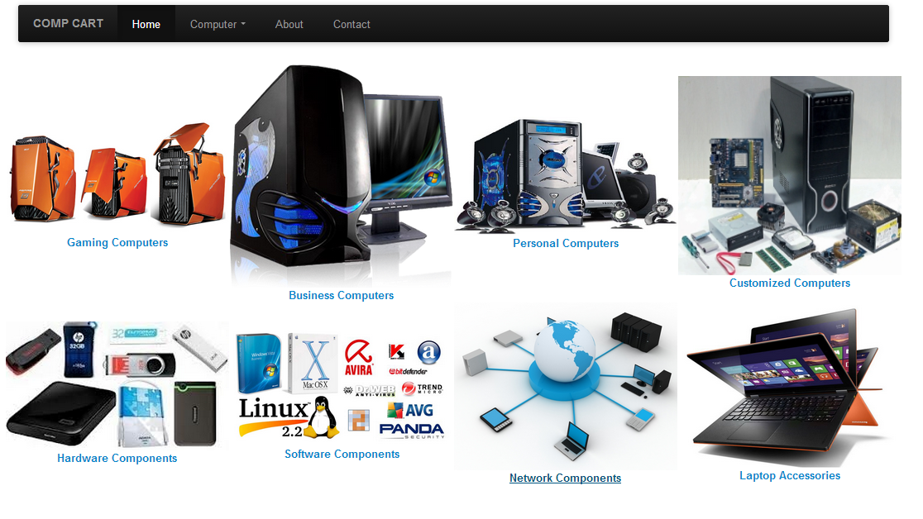

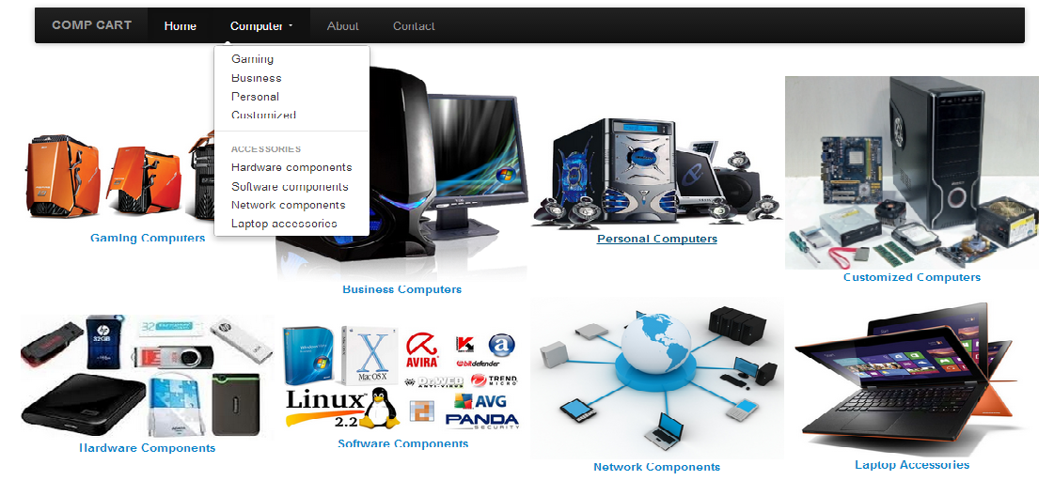

Admin Page:

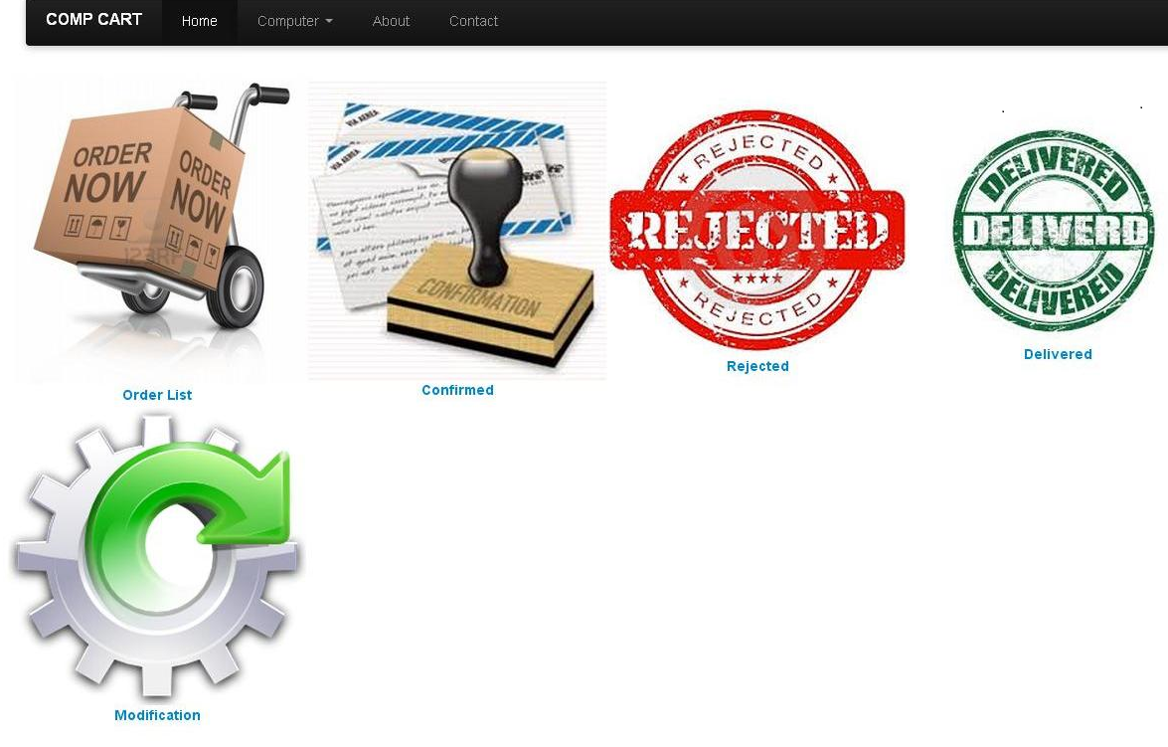

Confirm List Page

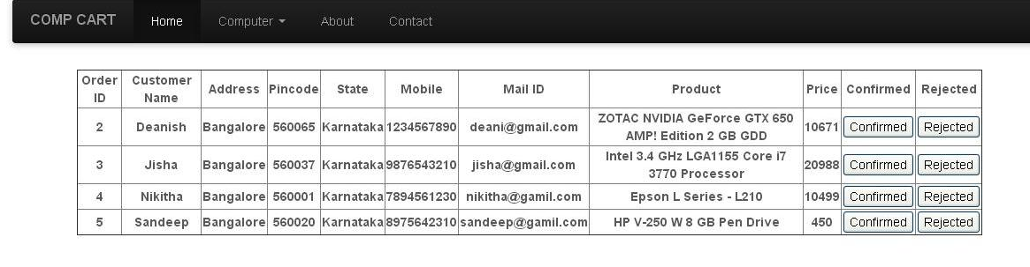

Modification Page:

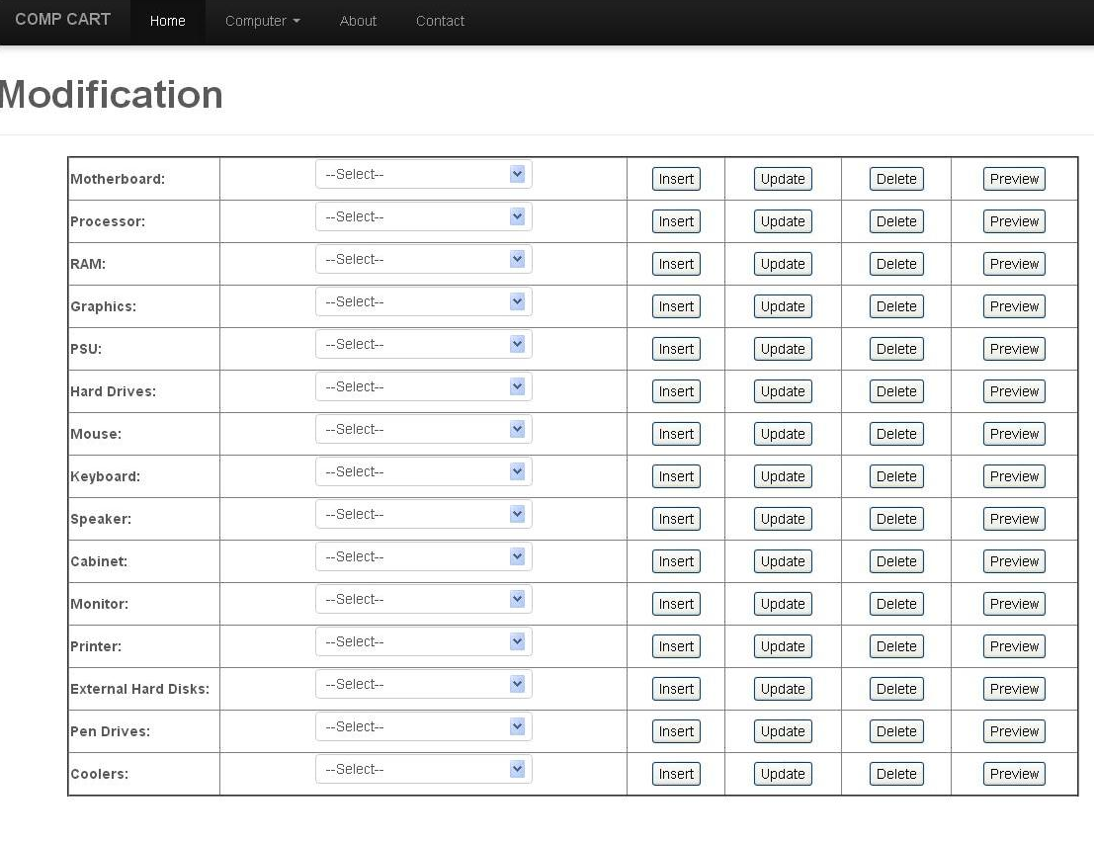

Contact Page:

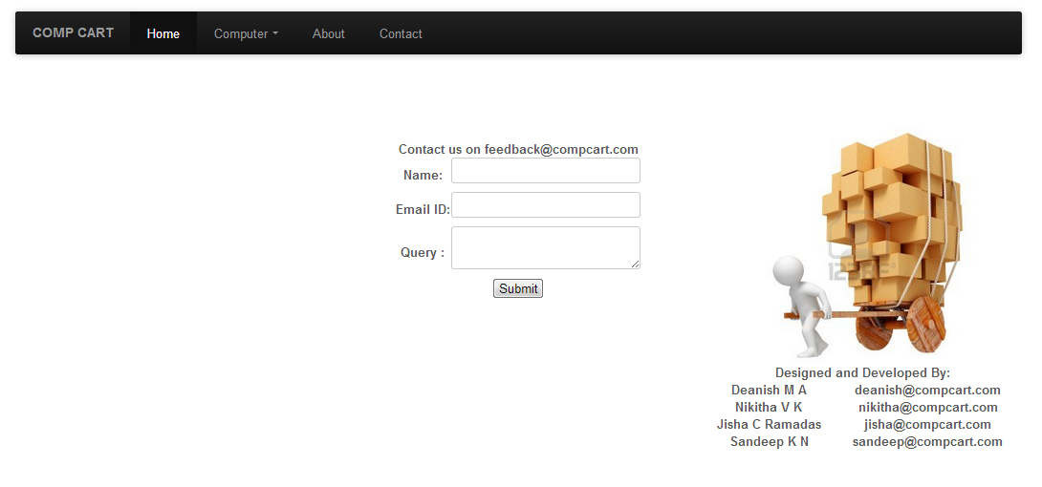

10. FUTURE ENHANCEMENT
It can be further extended to include the following
- Festive and Combo Offers
- E-Payment
- Comparison of products

11. CONCLUSION
Overall this is very informative project which gives a clear vision to the user to buy the required product within his range.Its very efficient in this materialistic world , as it saves your time by choosing the right product.

12. BIBLIOGRAPHY
12.1 BOOKS:
- Programming the world wide web – Robert W Sebesta

12.2 WEBSITES:
- www.w3schools.com
- www.getbootstrap.com
- www.github.com
- www.stackoverflow.com

